Nazarbayev Intellectual School of the Chemical-Biological direction of Almaty

The project "Qi Vita - a unique device that measures electro-puncture and pulse diagnostics and displays a diagnosis of a person on the smartphone"

Изображение выглядит как коллекция картинок

Описание создано с высокой степенью достоверности

**Thematic line:** medicine, hardware system, medical technology and technology

**Place of implementation:** Laboratory "Technotoria" under Nazarbayev Intellectual School of the Chemical Biological direction of Almaty.

**Participants of the project:** Keneshbekov Alimzhan, student of the 11th "L" class of Nazarbayev Intellectual School of the Chemical and Biological Direction in Almaty.

**Head of the work:** Mukanova Makpal, teacher of computer science in Nazarbayev Intellectual School of the Chemical and Biology Direction in Almaty

Almaty, 2018

Contents

**The urgency of the problem.** 3

**Purpose of the study.** 4

**Objectives of the study** 4

**Scientific novelty of the study** 5

**Practical significance.** 5

**Technology.** 6

**Results of the research.** 7

**Conclusions** 7

**Ways to improve.** 8

**References** 9

# **The urgency of the problem.**

The modern concept of restorative and alternative medicine provides for the need to consider the constitutional types of a person as significant predictors of predisposition to the development of various pathological conditions, the individual's reaction to risk factors, and, consequently, to the enhancement of the possibilities for personified prevention and diagnosis.

Restorative medicine provides for the priority use of non-drug diagnostic methods, among which a significant role is assigned to modern gadgets. Like any medical specialty, reflexotherapy contains a relatively specific diagnostic system - reflex diagnostics.

Specificity of reflex diagnosis is determined by its historical roots, derived from the general methodology of traditional eastern medicine, in particular - traditional acupuncture. Diagnostic findings are derived on the basis of an assessment of the state of the system of acupuncture canals. In the format of the general methodology of traditional oriental medicine, this approach allows us to identify the individual features of the course of the disease.

Traditional eastern pulse diagnosis, which differs significantly from the usual pulse study, is recognized by several researchers as the most adequate. However, the well-known schools of traditional oriental pulse diagnostics - Chinese, Tibetan, Indian, etc., differ in both the technique of palpation and the interpretation of the data obtained. It is emphasized that for mastering this diagnosis it is necessary to have a long-term training under the guidance of an experienced master, strict requirements are imposed on the functional state of the doctor himself and on the preparation of the patient for diagnosis. The inevitable subjectivity of the pulse determination of the diagnosis led to the development of a computer pulse meter that reproduces the main features of the eastern PD.

Another technology, more widely represented in rehabilitation medicine, is the development of instrumental methods of reflex diagnostics, technologies based on the measurement of electro-cutaneous resistance (ECS) in representative points of acupuncture (TA) - electropuncture diagnostics (EPD). In systematic studies, V.B. Lyubovtseva (1998), A.T. Neborskogo (1999), N.V. Spasova (2007) presented convincing evidence of the informative nature of electropuncture diagnostic methods and the advisability of their application in the format of problems of restorative medicine.

The commonly used criteria of a "physiological norm corridor" for a technology are often not acceptable for other technologies of the same class. The question of the comparability of the results of reflex diagnostics technologies belonging to different classes but intended to solve the same problem - the evaluation of the functional state of the system of acupuncture channels in general has not yet come to the attention of researchers. It should be borne in mind that in the parameters of reflex diagnostics reflecting the actual state of the organism, properties predetermined by the genotype, events of phenotypic induction, including perinatal programming and subsequent life conditions, are encrypted. Hence, serious diagnostic errors can occur with all the ensuing negative consequences.

These unresolved issues of the problem of reflex diagnostics, together with the insufficient general theoretical development of its modern natural science foundations, induce analysis and generalization of existing experience and the development of a unified methodology for their use in restorative medicine.

# **Purpose of the study.**

To develop a system for optimizing the choice of non-medicinal technologies of restorative medicine based on electropuncture, pulse diagnostics and functional state of the organism for increasing the effectiveness of diagnostic measures.

# **Objectives of the study**

• To study the correspondence of the state of vegetative tonus to specific constellations of indicators of electropuncture diagnostics in healthy people

• To investigate the possibilities of optimizing the reactions of the cardiovascular system during physical activity in healthy people, depending on the individual characteristics of the variability of the electrometric parameters of the acupuncture canals

• To study the dynamics of indicators of electropuncture diagnostics in healthy people in the process of mastering the skills of psychophysiological self-regulation

• To study the characteristic variants of constellations of indicators of electropuncture diagnostics in patients with various forms of chronic headaches and their dynamics under the influence of reflexotherapy

• Compare the results of a study of postural balance and muscle hypertension with electropuncture diagnostic data during osteopathic treatment of patients with chronic cephalalgia and cervicalgia

• Propose a method for determining a person's psycho-physiological constitution based on electropuncture diagnostic data, which ensures the selection of optimal personal prescribing tactics in restorative medicine

# **Scientific novelty of the study**

* Use of modern gadgets in the diagnosis of the body in humans.
* A technique and a mathematical apparatus for revealing abnormal, acupuncture channels that reflect the balance of activity of the sympathetic and parasympathetic tone of the autonomic nervous system has been developed. An original vegetative electropuncture index is proposed that allows obtaining quantitative characteristics of the balance states of the vegetative tone of a person based on the values ​​of skin resistance of biologically active measuring points belonging to categories of yin and yang.
* The effectiveness of the constitutionally conditioned choice of the electro-puncture formulation for optimizing the reactions of the cardiovascular system during exercise in healthy people is shown.
* The relationship between the indicators of electropuncture diagnostics and the improvement of the skills of psychophysiological self-regulation in healthy people is shown.
* The regular characteristics of the functional state of the system of active points are determined depending on the type of chronic headache and the changes in their patterns during restorative treatment.
* The model of the definition of a person's psycho-physiological constitution based on the data of electropuncture and pulse diagnostics providing a choice of optimal personal prescribing tactics in restorative medicine is presented.

**Practical significance.**

The results of the conducted studies allow:

* Reduce time and cost savings in case of mass surveys, primary requests for medical care and monitoring of patients at all stages of rehabilitation treatment and medical and social rehabilitation.
* More precisely define and specify the indications for specialized high-tech expensive studies.
* To provide a more reasonable choice of individual tactics of appointments aimed at increasing the reserve adaptive capacity of healthy people.
* Optimize adaptation programs for adaptation opportunities for general health and specialized activities, as well as rehabilitation and rehabilitation treatment in outpatient, inpatient and sanatorium-resort settings.

# **Technology.**

Arduino, two potentiometers, five resistors (91k, 100k, 150k, 62k, 62k, 3.3k, 10k), a switch indicator (microammeter), two switches, two power supplies were used to construct the circuit using the method of electropunctional diagnostics (Foll method), operational amplifier, General, probe, Bluetooth HM-10.

.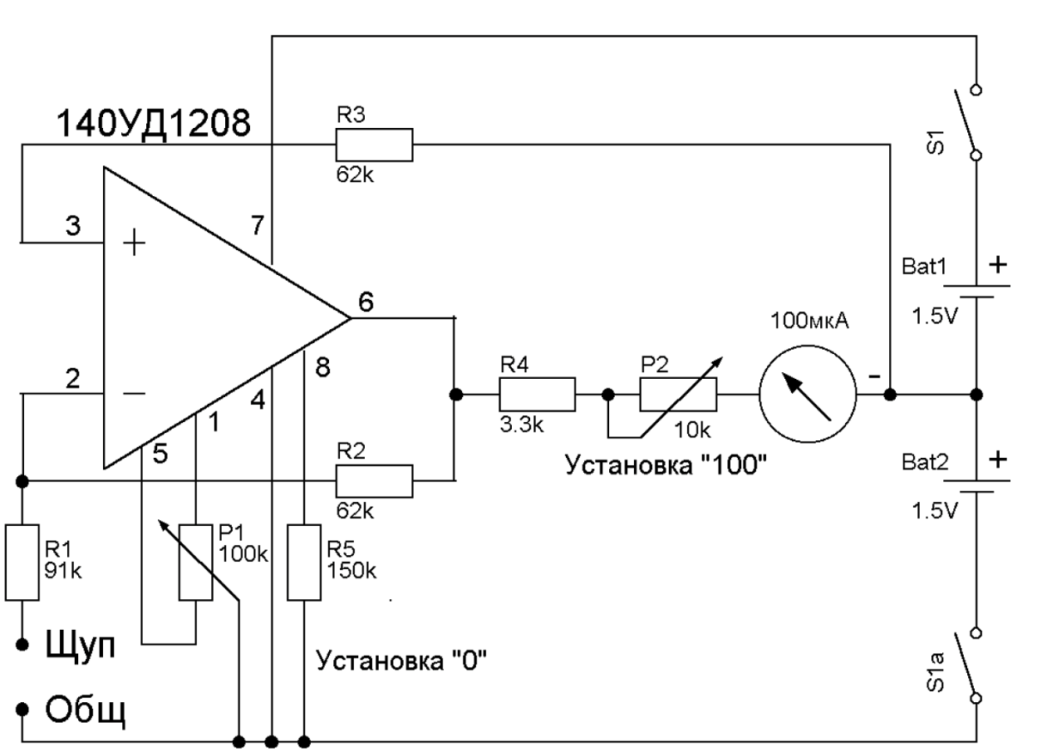

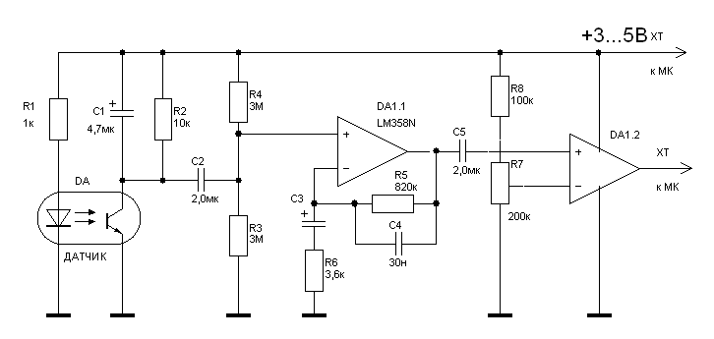***Figure 1. Diagram of electropunctional diagnostics***

***Figure 2. Diagram of heart rate monitor***

To create the project application, development environments were used, such as: Arudino IDE, LightBlue.

Изображение выглядит как снимок экрана

Описание создано с очень высокой степенью достоверности

***Figure 3. Application code***

# **Results of the research.**

After conducting research with some teachers and students of the Nazarbayev Intellectual School, namely with 248 people, we got a correct diagnosis in 208 of them. That is, the probability of finding the right diagnosis is 84%. In the future, it is planned to conduct in-depth studies together with laboratory assistants of Nazarbayev University, as well as with professors of the Kazakh National University named after Al-Farabi. In December 2017, a pilot experimental work will be carried out in polyclinic No. 1 in Almaty, where we will be able to test the technology and eliminate all the problems associated with inaccuracies in the structure of the hand of a single person.

# **Conclusions**

* Except for the original terminology, the methodology of traditional Chinese medicine corresponds to the modern theory of systems. The classical theory of acupuncture points and channels contains all the basic principles of describing living systems: purposefulness, hierarchy, structure, communication with the environment, plurality of descriptions.
* Traditional pulse and modern instrumental methods of reflex diagnostics correspond to three basic principles of system analysis: decomposition, analysis and synthesis. Reflex diagnostic technologies are forms of system analysis that provide a constitutional supranozologic approach to examining healthy people and patients and monitoring their functional state, which meets the targets and the methodology of restorative medicine.
* Based on the results of electropuncture diagnostics in 75% of practically healthy adults, abnormal constellations, electrometric parameters of acupuncture canals, reflecting a relatively stable component of a person's psycho-physiological constitution are revealed.
* Carrying out a functional test with physical activity makes it possible to identify the stably reproducible occurrence of abnormal constellations that characterize the typical response of the organism to homogeneous external disturbing and control actions, a relatively dynamic component of the psychophysiological constitution.
* The proposed original vegetative electropuncture index (VEP) makes it possible to obtain quantitative characteristics of the balance states of the vegetative tonus of a person based on the values ​​of the electrometric parameters of the measuring points of acupuncture canals belonging to the categories of yin and yang. According to the results of a single-factor analysis of variance of the vegetative nervous system balance by VEP and the stress index by the method of variability of the heart rhythm coincide.
* Conducting electropuncture at points selected in accordance with the identified dynamic component of the psycho-physiological constitution, more effectively optimizes the reactions of the cardiovascular system of healthy people with a repeated PWC170 sample compared to electropuncture performed using other previously recommended techniques.
* The results obtained in the study provide a basis for revising the established position on the need to continue treatment before the normalization of the functional state of all acupuncture canals. Attempts to normalize the indices of abnormal canals, which reflect a relatively stable component of a person's psycho-physiological constitution, can lead to aggravation of the patient's condition. The normalization of the indices of abnormal canals, which reflect the dynamic constitutional type, attests to correctly selected and effective therapeutic and prophylactic measures for the individual.
* The developed technology for obtaining and analyzing electropuncture diagnostics data allows to reveal the distribution characteristics of the activity of acupuncture canals, reflecting the relatively stable and relatively dynamic components of a person's psycho-physiological constitution, suitable for individualizing therapeutic and prophylactic purposes and activities.

# **Ways to improve.**

To improve experimental work, it is required, first, the most accurate and qualitative details for the construction of the device's microcircuit. Also, you need practical application in a qualified polyclinic with real patients and doctors. Knowing the diagnosis of a person, you can test the device and make sure of its real perspective application.

# **References**

1. Agasarov L.G. Osipova N.N. A brief guide to acupuncture. M., 1996.

2. Agasarov L.G. Current state and prospects of development of reflexotherapy in the country // Reflexotherapy. 2004, No. 1 (8). C.3-5.

3. Agadzhanyan NA Integrative medicine // Bulletin of new medical technologies. 1997. Vol. 1, No. 1-2.

4. Adaskevich VP, Katin A. Ya. Possibilities of electropuncture diagnostics by the Foll method in dermatological practice. Homeopathy and electropuncture, 1993, N2, P. 71-73.

5. Akio Sato: Nerve mechanisms of autonomic responses caused by somatic sensory stimulation. // Physiological Journal of. THEM. Sechenov. 81, No. 11, 1995, 56-69.

6. Aldersons AA Physiological mechanisms of electrodermal reactions. Diss. Doctor of medical sciences, 1990, 284 p.

7. Alekseev AA, Larionova IS, Dudina N.A. Mesodermal and alternative medicine. Moscow: Editorial URSS, 2001. - 408 p.

8. Andreev AA Hygienic substantiation of the express method of electro-puncture diagnostics of the functional state of young athletes. Author's abstract. diss. Candidate of Medical Sciences, 1989.

9. Anikieva E.Yu. Reference book on traditional and non-traditional medicine. -Moscow: EXPO-Press, 2002.

10. Archbishop Luke (Voino-Yasenetsky VF) Spirit, soul and body. - M., Orthodox St. Tikhon Theological Institute, 1997.

11. P. Badmaev P.A. Tibetan medicine: the main guide to the medical science of Tibet Chzhud-shi. - Rostov n / a: Phoenix, 2004. - 320s.140

12. Batha V.I. Prophylactic use of methods of reflex diagnostics and therapy // Reflexotherapy. 2003, No. 3 (6). C.9-12.

13. Barannikov A.S., Bely Yu.N., Grachev VI, Kislov V.Ya., Kolesov V. V., Panchenko I. P., Smirnov V. F. EPD of surgical pathologies and EHF-therapy of the process rehabilitation in the postoperative period. Millimeter waves in biology and medicine, 1999, N 2, P. 37-44.

14. Bessonov AE, Kalmykova EA, Semeniy A.T. Information radio wave therapy. User's atlas. M, 2007. 400s.

15. Bobrov IA, Gotovsky Yu.V., Experience in the treatment of acute myocardial infarction with the help of multi- and bioresonance therapy // Abstracts and reports of the VII International Conference. Theoretical and clinical aspects of bioresonance and multiresonant therapy .. - M .: IMEDIS, 2001. - P. 219-224.

16. Bobrov IA, Gotovsky Yu.V., Mkhitaryan K.N. Meridional system, elements and wonderful meridians in the light of modern theories of organism regulation. // Theses and reports of the VIII International Conference. Theoretical and clinical aspects of bioresonance and multiresonant therapy. - M .: IMEDIS, 2002. - P.241-284.

17. Bobrov IA, Gotovsky Yu.V., Ilyukhin VV, Mkhitaryan K.N. Implicit body time and treatment of the organism in its implicit time // Abstracts and reports of the VIII International Conference. Theoretical and clinical aspects of bioresonance and multiresonant therapy. - Moscow: IMEDIS, 2002. - P. 330-352.